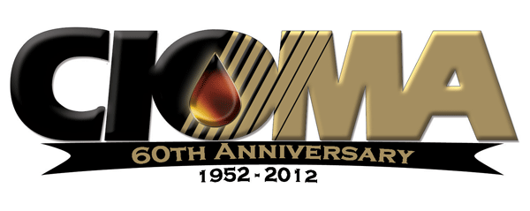

October 3, 2012

Mr. Rob Oglesby
Executive Director
California Energy Commission
1516 Ninth Street, MS-29
Sacramento, CA 95814-5512

Mr. James Goldstene
Executive Officer
California Air Resources Board
1001 "I" Street
Sacramento, CA 95814
Via Email

Subject: Immediate Request for Emergency Waiver – Allowance for Sale and Manufacture of Off-Spec California Gasoline

Mr. Oglesby and Goldstene:

On behalf of the members of California Independent Oil Marketers Association (CIOMA) and the California Service Station and Auto Repair Association (CSSARA) we ask you to expedite a waiver or whatever clearances are necessary to allow sale and manufacture of California off-spec gasoline in this state to alleviate possible fuel supply disruptions. We are receiving numerous reports of unbranded fuel shortages, or outright unavailability, especially in the southern California region. We are unclear as to what exactly is causing this problem, but it appears technical difficulties at several California refineries, in conjunction with tight US supply of gasoline, is contributing to short fuel supplies. We understand the Energy Commission is undertaking an analysis of this situation and performing supply inventory inquiries.

Whatever the cause, if there are tight fuel supplies granting waivers or allowances for out-of-spec gasoline is needed to assure continuing flow of fuel to California motorists. Several of our Southern California members are reporting that they are unable to obtain supply of unbranded fuel. (As a side note: unbranded wholesale prices have rocketed to unprecedented differentials between unbranded and dealer-tank-wagon prices. This will likely have an upward pressure on gasoline prices as unbranded fuel is typically the cheapest fuel available, day-in and day-out.)

We ask your IMMEDIATE ATTENTION to this request. Time is of the utmost essence.

You may contact me at any time via cell phone (916) 207-5999, or email, jaymck@cioma.com.

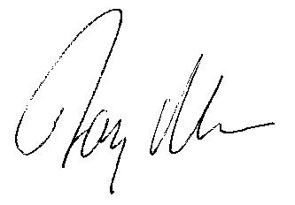
Jay McKeeman, Vice President Government Relations & Communications

cc: Cliff Rechtschaffen, Governor’s Office
CIOMA Board of Directors

